2017 Applied Maths Higher Level Questions
1.
(a)
A car passes four collinear markers A, B, C, and D while moving in a straight line with uniform acceleration. The car takes t seconds to travel from A to B, t seconds to travel from B to C and t seconds to travel from C to D.
If |AB| + |CD| = k|BC|, find the value of k.

(b)
A baggage chute has two sections, PQ and QR, as shown in the diagram.
PQ is smooth and is a quarter circle of radius r.
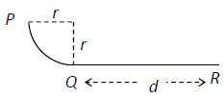
QR, of length d, is rough and horizontal.
The coefficient of friction between the bag and section QR is μ.
A bag of mass m kg is released from rest at P and comes to rest at R.
Find
- the speed of the bag at Q in terms of r
- d in terms of μ and r.
- The speed of the bag when it is halfway along QR is 7 m s^{–1}.
Find the value of r.

2.
(a)
A girl cycles at a constant speed of 5 m s^{–1} on level ground.
When her velocity is 5 j m s^{–1} the velocity of the wind appears to be 3u i− 4u j,
where u is a positive constant.
When the girl cycles with velocity −3 i + 4 j, the velocity of the wind appears to be v i, where v is a positive constant.
Find the magnitude and direction of the velocity of the wind.

(b)
A ship P is moving north at 15 km h^{–1}. A second ship Q is 10 km west of P and appears to be moving relative to P in a direction east 60° south at 15√3 km h^{–1}.
- Find the velocity of Q.
- Two minutes after the time when P and Q are closest to each other, P is east θ° north of Q.
Find the value of θ.
- If Q can be seen from P for 12 minutes, find the distance between P and Q at the end of this time.

3.
(a)
A particle is projected with speed $\frac{\sqrt{9gh}}{2}$ from a point P on the top of a cliff of height ℎ.
It strikes the ground a horizontal distance 3ℎ from P.
- Find the two possible angles of projection.
- For each angle of projection find, in terms of ℎ, the time it takes the particle to reach P.

(b)
A plane is inclined at an angle θ (where θ < 45°) to the horizontal.
A particle is projected up the plane with initial speed u m s^{–1} at an angle θ to the inclined plane.
The plane of projection is vertical and contains the line of greatest slope.
- Show that the range on the inclined plane is $\frac{2u^{2}\cos{2θ\sin{θ}}}{g\cos^{2}{θ}}$.
(ii) If the particle strikes the inclined plane at right angles show that the range is $\frac{u^{2}}{g\sqrt{3}}$.

4.
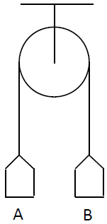
(a)
Two scale pans A and B, each of mass m kg, are attached to the ends of a light inextensible string which passes over a light smooth fixed pulley.
They are held at the same level, as shown in the diagram.
A mass of 3m kg is now placed on A.
The system is released from rest.
Find
- the tension in the string in terms of m
- how far B has risen when it reaches a speed of 0∙4 m s^{–1}
- the reaction on the 3m kg mass in terms of m.

(b)
A smooth wedge, of mass 4m and slope β, rests on a smooth horizontal surface.
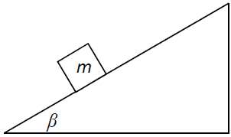
A particle of mass m is placed on the smooth inclined face of the wedge.
The system is released from rest.
- Show, on separate diagrams, the forces acting on the wedge and on the particle.
- The particle moves with acceleration p relative to the wedge and the wedge moves with acceleration kp cos β.
Find the value of k.
- Show that $p=\frac{49\sin{β}}{4+\sin^{2}{β}}$

5.
(a)
A small smooth sphere A, of mass 1.5 kg, moving with speed 6 m s^{–1}, collides directly with a small smooth sphere B, of mass m kg, which is at rest.
After the collision the spheres move in opposite directions with speeds v and 2v, respectively.
80% of the kinetic energy lost by A as a result of the collision is transferred to B.
The coefficient of restitution between the spheres is e.
Find
- the value of v
- the value of e.

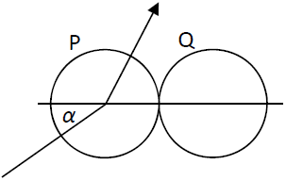
(b)
A small smooth sphere P, of mass 3m, collides obliquely with a small smooth sphere Q, of mass 7m, which is at rest.
Before the collision the velocity of P makes an angle α with the line joining the centres of the spheres.
After the collision the speed of Q is v.
The coefficient of restitution between the spheres is $\frac{2}{7}$.
- Find, in terms of v and α, the speed of P before the collision.
- If α = 30° find the angle through which the direction of motion of P is deflected as a result of the collision.

6.
(a)
Two particles moving with simple harmonic motion pass through their centres of
oscillation at the same instant.
They next reach their greatest distances from their centres of oscillation after 2 seconds and 3 seconds respectively, having been at the same distance from their centres of oscillation after 1 second.
Find the ratio of their amplitudes.

(b)
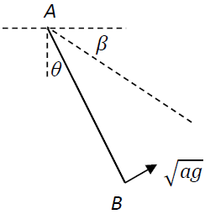
One end A of a light inextensible string of length 3a is attached to a fixed point.
A particle of mass m is attached to the other end B of the string.
The string makes an angle θ with the vertical.
The particle is held in equilibrium with the string taut and cos θ = $\frac{2}{3}$

The particle is then projected with speed$\sqrt{ag}$, in the direction perpendicular to AB, as shown in the diagram.
In the subsequent motion the string remains taut
When AB makes an angle β below the horizontal, the speed of the particle is v and the tension in the string is T.
- Show that $v^{2}=3ag\left(2\sin{β}-1\right)$.

- Find the minimum value and the maximum value of T.

7.
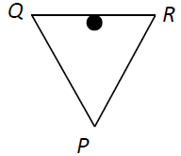
(a)
Three equal uniform rods, QP, QR, RP, each 30 cm long and of weight 6 N, are freely jointed at P, Q and R to form a triangle.
The triangle is placed over a smooth peg at the midpoint of QR, so that P is below QR.
Find the reaction at Q and the reaction at P.

(b)
Two equal uniform rods, AB and BC, of length 2a and weight W, are freely jointed at B.
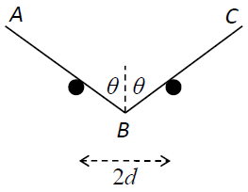
They rest in equilibrium on two smooth pegs at the same horizontal level which are 2d apart.
Each rod is inclined at θ° to the vertical. B is below A and C.
Prove d = a $\sin^{3}{θ}$.

8.
(a)
Prove that the moment of inertia of a uniform rod, of mass m and length 2l, about an axis through its centre, perpendicular to its plane, is $\frac{1}{3}$ ml².

(b)
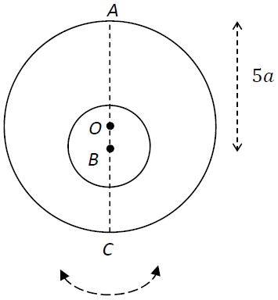
A uniform circular disc has mass 4m, centre O and radius 4a.
A circular hole of radius 2a is made in the disc.
The centre of the hole is at the point B on the diameter AC, where |AB| = 5a, as shown in the diagram.
The resulting lamina oscillates about a fixed smooth horizontal axis which passes through A and is perpendicular to the plane of the lamina.
- Find the moment of inertia of the lamina about the axis of rotation.
- The lamina is hanging at rest with C vertically below A when it is given an angular velocity$\sqrt{\frac{11g}{23a}}$.
The lamina turns through an angle θ before it comes to instantaneous rest.
Show that the distance of A from the centre of gravity of the lamina is $\frac{11a}{3}$.

- Find the value of θ.

9.
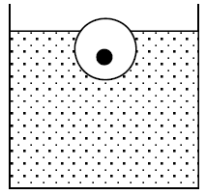
(a)
A spherical piece of ice of radius 10 cm has a piece of iron embedded in it and floats, in water, with 95% of its volume immersed.
The density of the iron is 7800 kg m^{–3} and the density of ice is 918 kg m^{–3} .
Find the volume of the iron.
[Density of water = 1000 kg m^{–3}]

(b)
A solid iron cylinder of diameter 25 cm and height 10 cm is placed upright in an empty cylindrical tank of diameter 30 cm.
Mercury is now poured into the tank until the iron begins to float.
The density of iron is 7800 kg m^{–3} and the density of mercury is 13 600 kg m^{–3} .
- Calculate the depth of the mercury.
- Oil, of density 1030 kg m^{–3}, is now poured on top of the mercury until the upper face of the iron cylinder is just level with the surface of the oil.
Find the volume of oil required.

10.
(a)
A particle starts from rest and moves in a straight line with acceleration (25 – 10v) m s^{–2}, where v is the speed of the particle.
- After time t, find v in terms of t. $\left(Note:\int{\frac{dx}{a+bx}}= \frac{1}{b}ln\left[a+bx\right]+c\right).$

- Find the time taken to acquire a speed of 2∙25 m s^{–1} and find the distance travelled in this time.

(b)
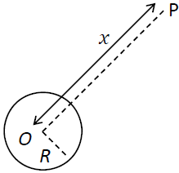
A spacecraft P of mass m moves in a straight line towards O, the centre of the earth.
The radius of the earth is R.
When P is a distance x from O, the force exerted by the earth on P is directed towards O and has magnitude $\frac{k}{x^{2}}$, where k is a constant.
- Show that k = mgR².
- P starts from rest when its distance from O is 5R.
Find, in terms of R, the speed of P as it hits the surface of the earth, given that air resistance can be ignored.

